**Cal Poly Pomona**

**College of Engineering**

**Electrical and Computer Engineering Department**



ECE 480-01

Software Engineering

Development Project

Scantron Scanning & Grading Application Project Report

By: Group 3

Nolan Chang

Rheza Budiono (Lead)

Bryan Chan

Jared Buo-en Huang

Mohammed Mirza

To: Dr. Tim Lin

May 30, 2018

# Table of Contents

Table of Contents 2

Objectives and Requirements 3

Introduction 3

Executive Summary 3

Future Development 4

Implementation 1 5

Implementation 1: Advantages and Disadvantages 9

Implementation 2 10

Implementation 2: Advantages and Disadvantages 17

# Objectives and Requirements

This software project’s goal is to allow an instructor or teacher’s aide to be able to quickly and efficiently determine the number of incorrect answer students have filled on scantrons for tests without the use of expensive, specialized (and at most times, proprietary) machinery. This program should read in an answer key and submissions, be able to compare submissions to the answer key, and output how many questions the student marked incorrect relative to the answer key.

# Introduction

Two implementations were developed in parallel as solutions to meet this objective. Note that for the first implementation, Python 2 was used; for the second implementation, Python 3 was used. Both were used in conjunction with OpenCV to implement the features outlined in the Objectives and Requirements section. Due to the version difference, there may be different function calls, despite them being essentially the same function and yielding identical outputs/results. **Figure 0-1** below shows the initial imported libraries that are required for both implementations to function properly.

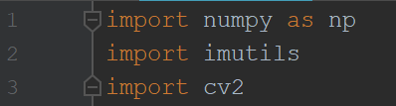

**Figure 0-1.** *Imported Libraries*

Both implementations take a known answer key image and compare it to a certain submission using OpenCV functions. Through this comparison, we find the differences between the submission and answer key and can then determine the number of errors present in the submission. How each implementation works is elaborated on in their respective sections.

Both implementations are demonstrated and tested with a single image of a scantron that was filled in digitally, such that both images are identical other than the filling of the answer marks. This way, we can ensure consistent results.

# Executive Summary

Both implementations work as intended to different extents. Each have their advantages and disadvantages respective to the methodologies employed. For the first implementation, a bitwise AND operation is used to concatenate the two graphics files into a single binary image. This implementation yields cleanly defined edges (ideal for user readability) and reliability under certain restrictions, but lacks freedom and practicality. The second implementation yields a final image that is more or less indecipherable to a human observer. However, it allows for haphazardly taken images to be compared (assuming the contour detection and perspective transform algorithm functions as intended). In theory Implementation 2 is more robust but in practice requires the taken images to be extremely similar in positioning (e.g. if all images are scanned in an actual scanner)

# Future Development

Both implementations are good proof-of-concepts as solutions to the problem proposed. However, both need refinement.

Implementation 1 needs consistently defined images as inputs. Any sort of variation or offset between the two will yield disastrous results. Fortunately, this can be fixed with many different methods. A predefined border for automatic image acquisition, similar to the Bank of America mobile check depositing functionality, can be implemented in the camera window. Combined with edge detection, the camera can automatically take a picture once the four edges of the scantron are intersecting with the boundaries of the border. While this may not result in two images of entirely identical dimension and rotation, it would limit the error to a point that would render the proposed code functional. Alternatively, a Region of Interest (ROI) could be defined to take into account only the contents of the answer choices and regard everything else as unnecessary information. This would limit the number of false positives detected in areas of the scantron that are not used, such as the instructions and identification fields. These restrictions limit the first implementation to a strictly theoretical application.

Instead of adding more functionality, implementation 2’s perspective transform algorithm for cropping needs refinement and further development. The contour detection algorithm needs to be more robust and more/better filters need to be applied to the image prior to the contour detection algorithm.

Both implementations could be scaled up such that a single answer key can be compared to an entire classes worth of completed scantrons, while outputting a given grade for each student. This would greatly increase efficiency of the application and vastly improve its real-world application.

In addition, both implementations could use some cosmetic touches such as a more sophisticated GUI as well as a built-in camera application that allows the pictures of the scantrons to be taken with the program itself using a computers camera (if available). This idea was toyed with during development and functioning code for it using OpenCV was written. However, the cropping algorithms both implementations use are not sophisticated enough to compensate for the shoddy picture quality that would result from a dimly lit picture taken using a computer’s webcam.

# Implementation 1

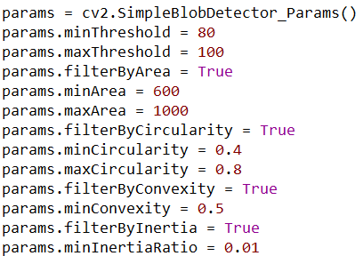

**Figure 1-1.** *Parameterization of the SimpleBlobDetector()*

For this implementation, the parameters are set in a way to detect blobs that form a rectangular shape with an area range of 600 to 1000 pixels. The threshold is set to detect a brightness range (ideally in grayscale). However, since this implementation converts the input image into a binary image (i.e., a quantization level of 1), this threshold is arbitrary as long as it does not detect the color white. To err on the side of caution, the minimum and maximum are both set to an upper range to ensure it only detects the blackened portions of the image. The circularity is set to a range between 0.4 and 0.8 to search for shapes resembling either a triangular or rectangular (perfect rectangle defined as 0.765). The convexity is set halfway at 0.5 to allow for some irregularities in the blob to be ignored. Setting the convexity its maximum of 1 would assume too ideal of a situation, leaving no room for human error. Finally, the minimum inertia is set to 0.01, which allows for the program to detect blobs regardless of how elongated they are.

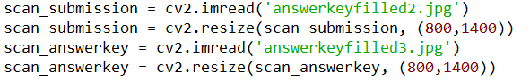

**Figure 1-2.** *Scantron image reading and standardization*

In this block of code, two predefined graphics files are read by the program and placed into a dynamically allocated array that comprises each pixel intensity. To aid with standardizing image sizes, each is resized to an image that is 800 by 1400 pixels. This standardization process will aid in providing accurate masks for the masking process mentioned further in this report.

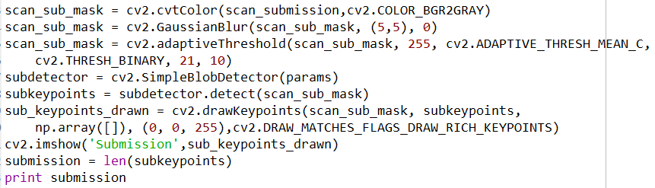

**Figure 1-3.** *Graphics file masking preparation and blob detector key point drawing for the submission scantron*

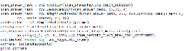

**Figure 1-4**. *Graphics file masking preparation and blob detector key point drawing for* *the answer key*

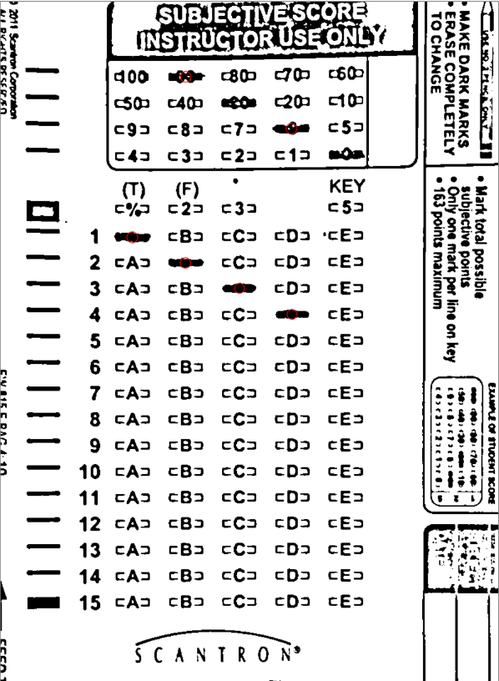  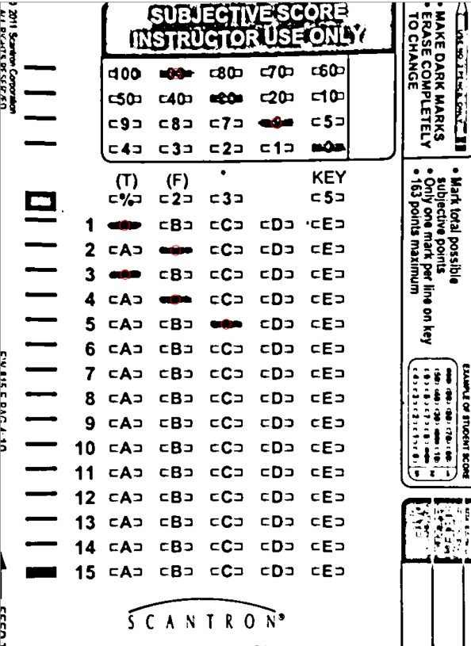

**(a)     (b)**

**Figure 1-6. *(a)*** *Submission scantron with drawn key points* ***(b)*** *Answer key scantron with drawn key points*

Here, the graphics files for both the submission and answer key scantrons are prepared for masking. Initially, the images are in the 3-channel RGB format. This is not ideal for the blob detection algorithm, so they are instead converted to a grayscale image. Next, a Gaussian blur is applied to remove any sharp contrasts or noise in the images, and to facilitate more defined areas of contrast. To provide an even clearer distinction between color contrasts, a threshold is applied. The thresholding method involves taking a grayscale or color image input and setting all pixels with intensity values below a certain threshold to a background color. Conversely, all pixel with intensity values above the threshold are set to the foreground color. This essentially turns the grayscale images into binary image, where 0 (black) and 255 (white) are the only two color intensities recognized. Unfortunately, this also produces result whose thresholds are calculated on an image-by-image basis. This is good for separating an object from its background, but does a poor job reading pronounced text. To remedy this, adaptive thresholding is used instead. Adaptive thresholding is applied on a pixel-by-pixel basis and accurately displays outlines. This provides textual clarity for the images.

From this point, the simple blob detector that is initialized with the set of parameters shown previously is instantiated. It detects the interest points (i.e., key points) of the images that match its parameters. These key points are data structures that provide information about the blob, such as coordinates, size, angle, response, and identification. Using the binary images and the key point arrays extracted from them, the key points are subsequently drawn on the images themselves using the function drawkeypoints(). Ideally, the number of key points detected is equivalent to the number of answers filled in for the submission and the answer key. Note that it is entirely possible for false positives in either image to be detected. This issue will be discussed in a later section.

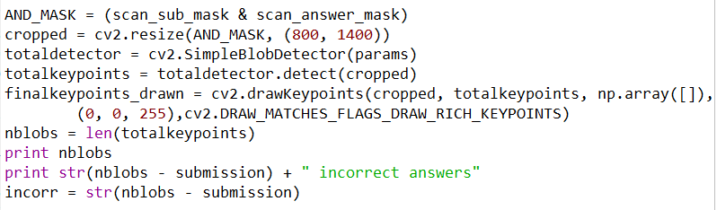

**Figure 1-7.** *Masking and final key point drawing for the masked image*

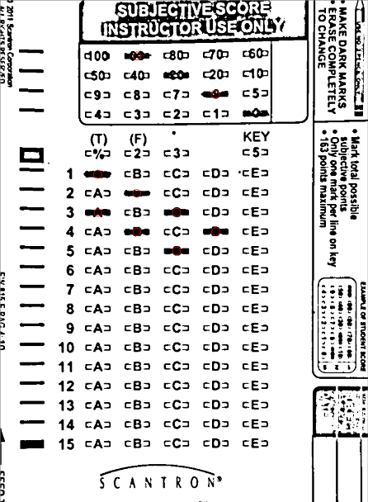

**Figure 1-8.** *Final masked image with drawn key points*

At this point, the two separately acquired images are ready for masking. In this implementation, a bitwise AND operation is used to combine the submission and answer key into a single binary image. Since the AND operation chooses the lower of the two pixel intensities, the final image effectively concatenates the two images together. Essentially, the filled-in answer choices on the submission and answer key both show up in the final masked image. From here, the same key point detection algorithm is implemented and the total number of key points for the masked image is saved in the variable *nblobs*.

From here, the output is calculated from simple mathematics and logic. The final image contains the total number of distinct key points. This can be subtracted by the key points from the submission image to obtain the total number of incorrect answers. For this, we assume that the answer key is ideal, only detecting the filled-in answers as key points. In this scheme, the number of false positives for the submission do not matter. They will be detected in the final image and subtracted by the number of submission key points, yielding a correct answer.

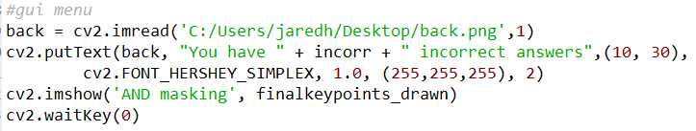

**Figure 1-9(a).** *GUI construction*

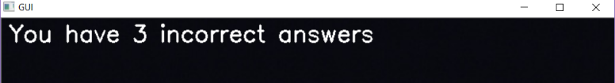

**Figure 1-9(b).** *Example GUI output*

The final segment of code simply deals with GUI development for user readability purposes. A background must be provided for the window to be created and a text string is drawn.

## Implementation 1: Advantages and Disadvantages

In theory, this implementation is more reliable. Since the masking uses a bitwise AND operation, the sizes of the filled-in answer choices do not need to be consistent. The largest blob will always be brought to the forefront and, in the worst case, one will be overlaid over the other. Additionally, the final image possesses incredible clarity far beyond expectations. Naturally, this is ideal for user readability, and can even be used for more accurate implementations of computer vision algorithms in future implementations. Unfortunately, the major drawback with this method of masking is that the program only works under a set of restrictions. First, both scantrons being fed as inputs must be ideal. Their characteristics must match up perfectly, or at least with very little deviation, in order for false positives to not be read. If the scantrons are not perfectly sized, the final image will result in a mask that is offset, potentially forming blobs large enough to be read whereas they were previously too small. An example of this phenomenon is shown in **Figure 1-10**. Secondly, larger scantrons cannot be read. This is more of a hardware issue, as the camera cannot take pictures encapsulating the entire scantron in the frame without lowering the resolution to a point that the program cannot read the filled-in answers. To fix this, the shorter fifteen-question version of the scantron was used.

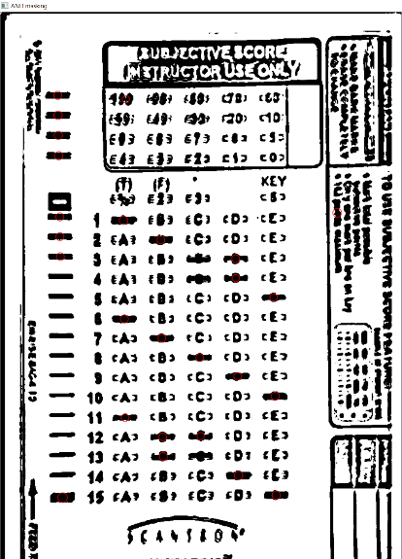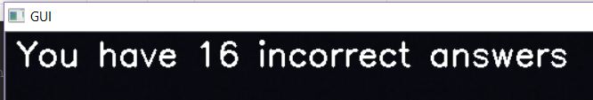

**Figure 1-10***. Incorrect final image key points because of imperfect input images*

# Implementation 2

The second implementation developed also uses the same blob detection functions as implementation 1. One of the key differences is that this second implementation relies on using a perspective transform to more ideally line up both images of scantrons.

To implement the perspective transform, two functions were implemented, shown in **Figure 2-1** and **2-2**.

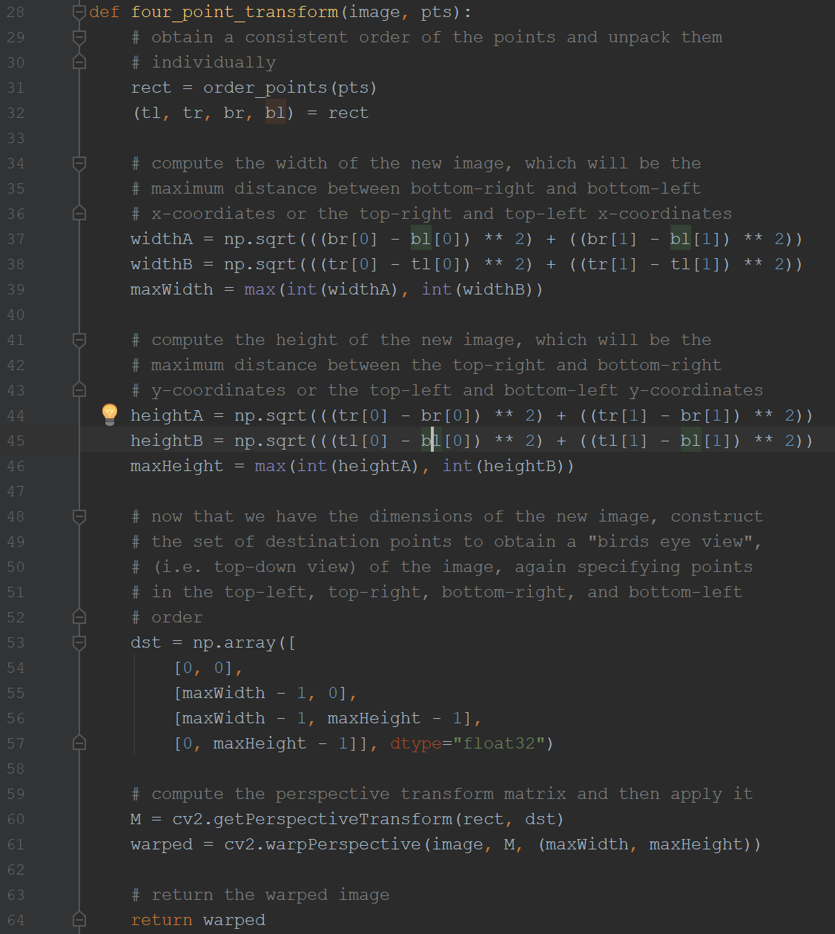

**Figure 2-1.** *Four Point Transform Function*

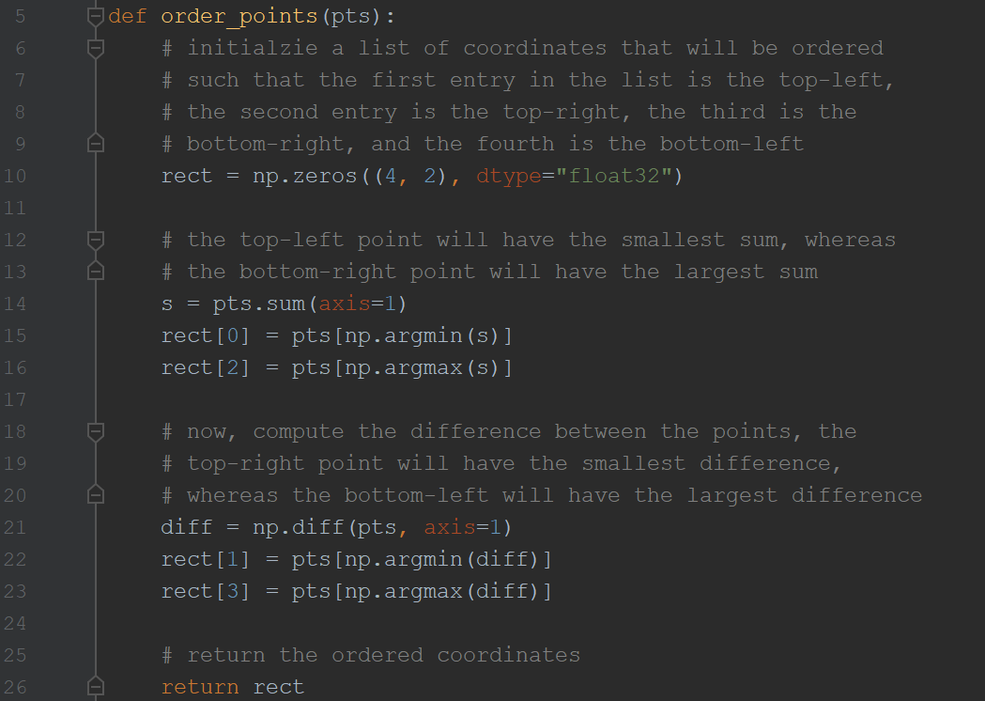

**Figure 2-2.** *Order Points Function*

The four point transform function utilizes OpenCV’s getPerspectiveTransform and warpPerspective functions in order to ensure that we have a consistent “bird’s eye view” of the scantron where ever the scantron may be in the image and whatever orientation it is in. This function requires the four corners of the object (the scantron) in order to properly. The four corners of the object need to be properly ordered before being used for the perspective transform. Therefore, the code in **Figure 2-2** of the Order Points Function will ensure that the coordinates of the 4 corners of the scantron are in the proper order such that the OpenCV functions will work.

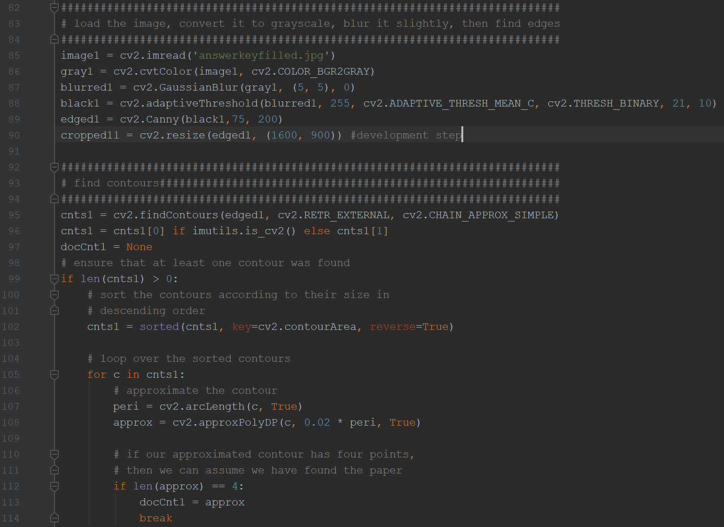

**Figure 2-3.** *Obtaining Contours*

As far as obtaining the corners of the scantron, the code shown in **Figure 2-3** was used. The particular snippet of code shown in **Figure 2-3** begins by reading in the image (“answerkeyfilled.jpg” in this case) and applies several alterations and filters to it. We first convert it to grayscale in line 86. A gaussian blurring filter is then applied to remove noise in line 87. The adaptiveThreshold function in line 88 allows us to strongly define the contours of the objects (particularly the scantron) in the image. And finally, the canny filter in line 89 is a high pass image filter that results in an edge-detected image. Line 90 was only used as a debugging tool to view the resulting image. Lines 95 to 114 are used to find the contours of the resulting edge-detected image and saves it into the doCnt1 variable. This variable then defines the corners of the scantron.

This code from lines 82 to 114 is repeated for the second image “answerkey.jpg” which is the image that “answerkeyfilled.jpg” will be graded against. All intermediate step variables for “answerkey.jpg” are followed by a 2 instead of a 1 (e.g. black2 instead of black1). For clarity and transparency, all intermediate images (image1, gray1, blurred1, black1, edged1, image2, gray2, blurred2, black2, edged2) generated will be shown in **Figures 2-4** to **Figure 2-13**.

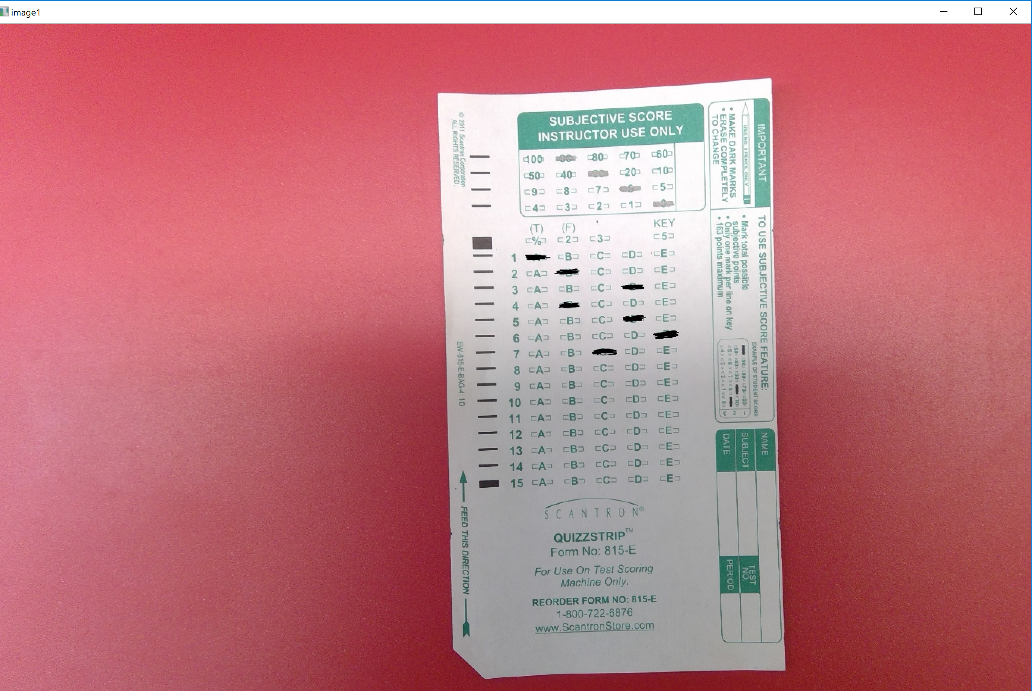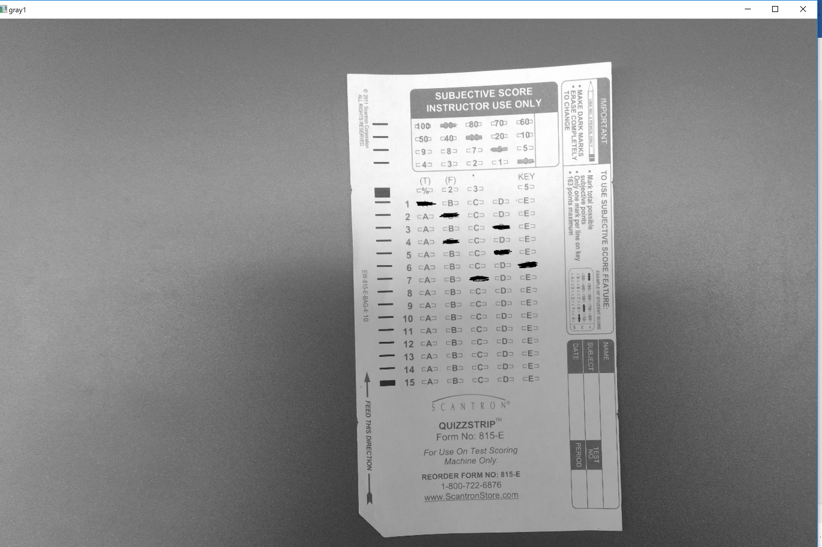

**Figure 2-4.** *image1* **Figure 2-5.** *gray1*

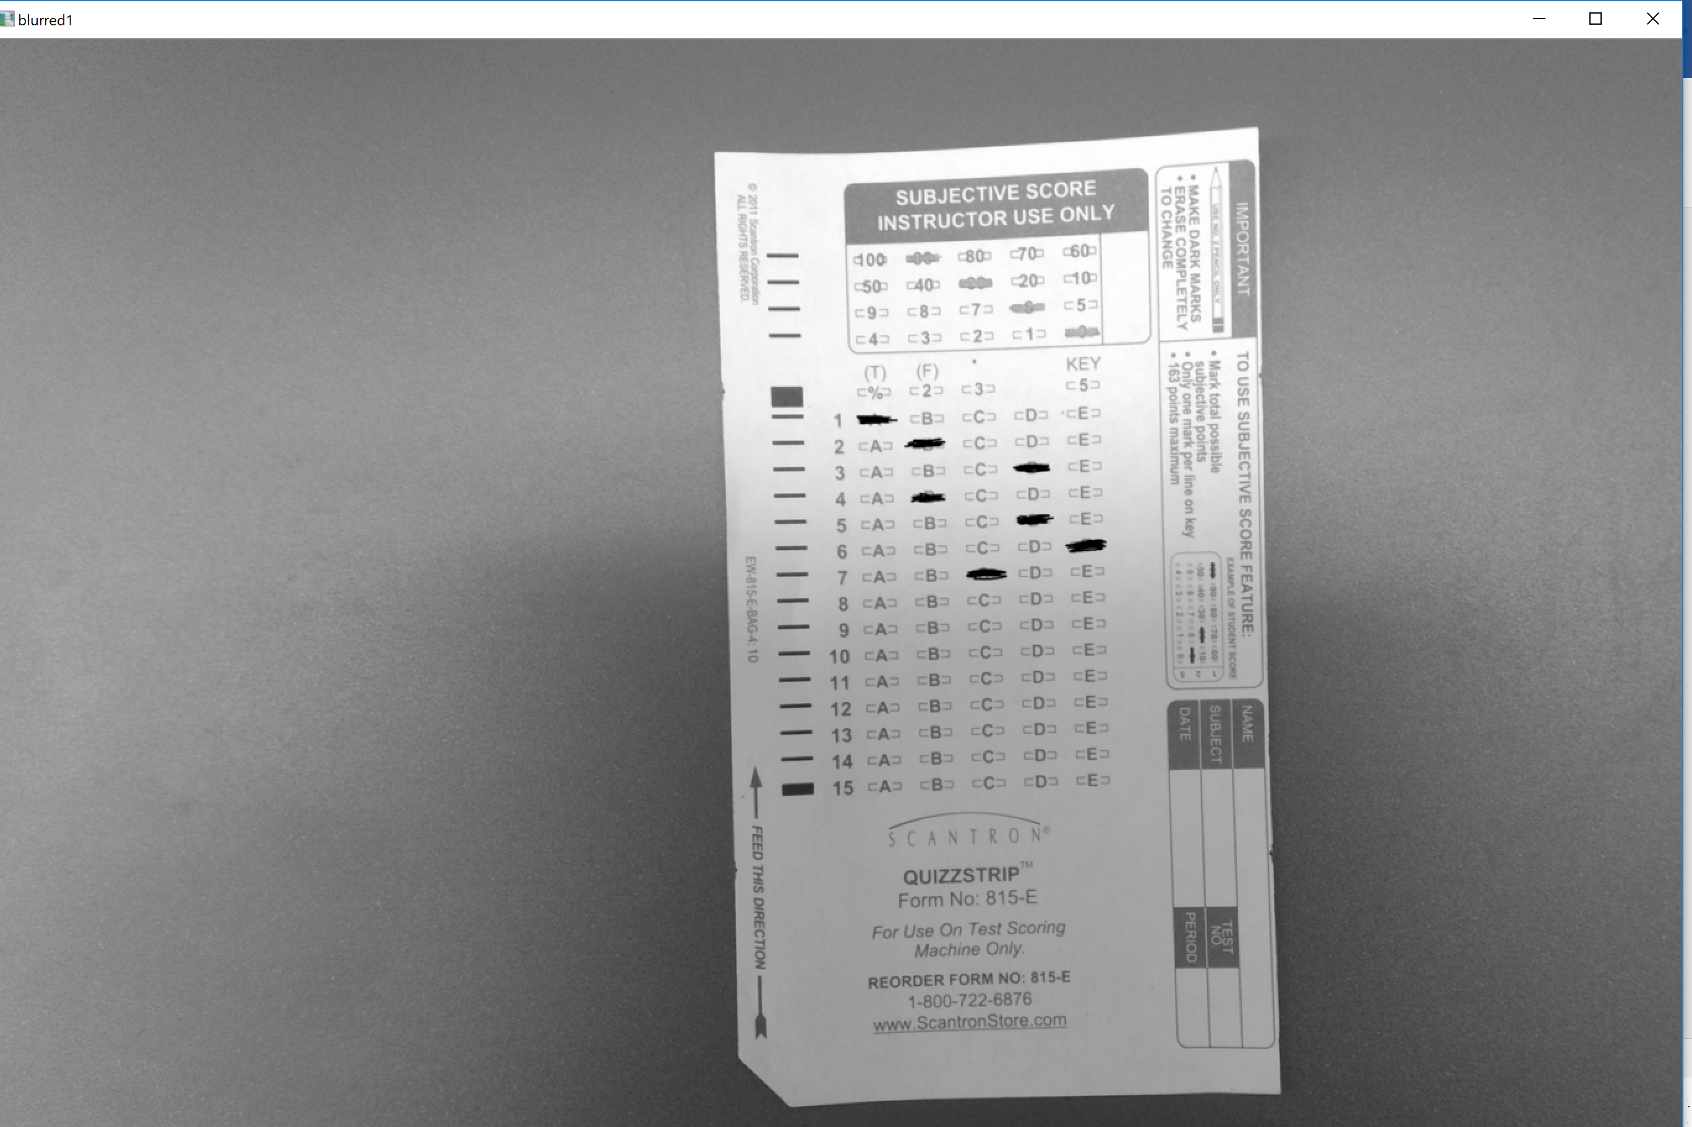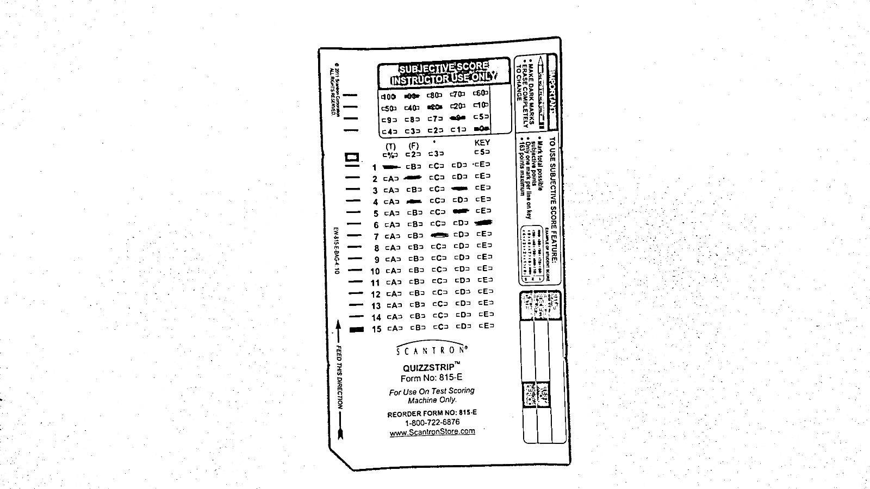

**Figure 2-6.** *blurred1* **Figure 2-7.** *black1*

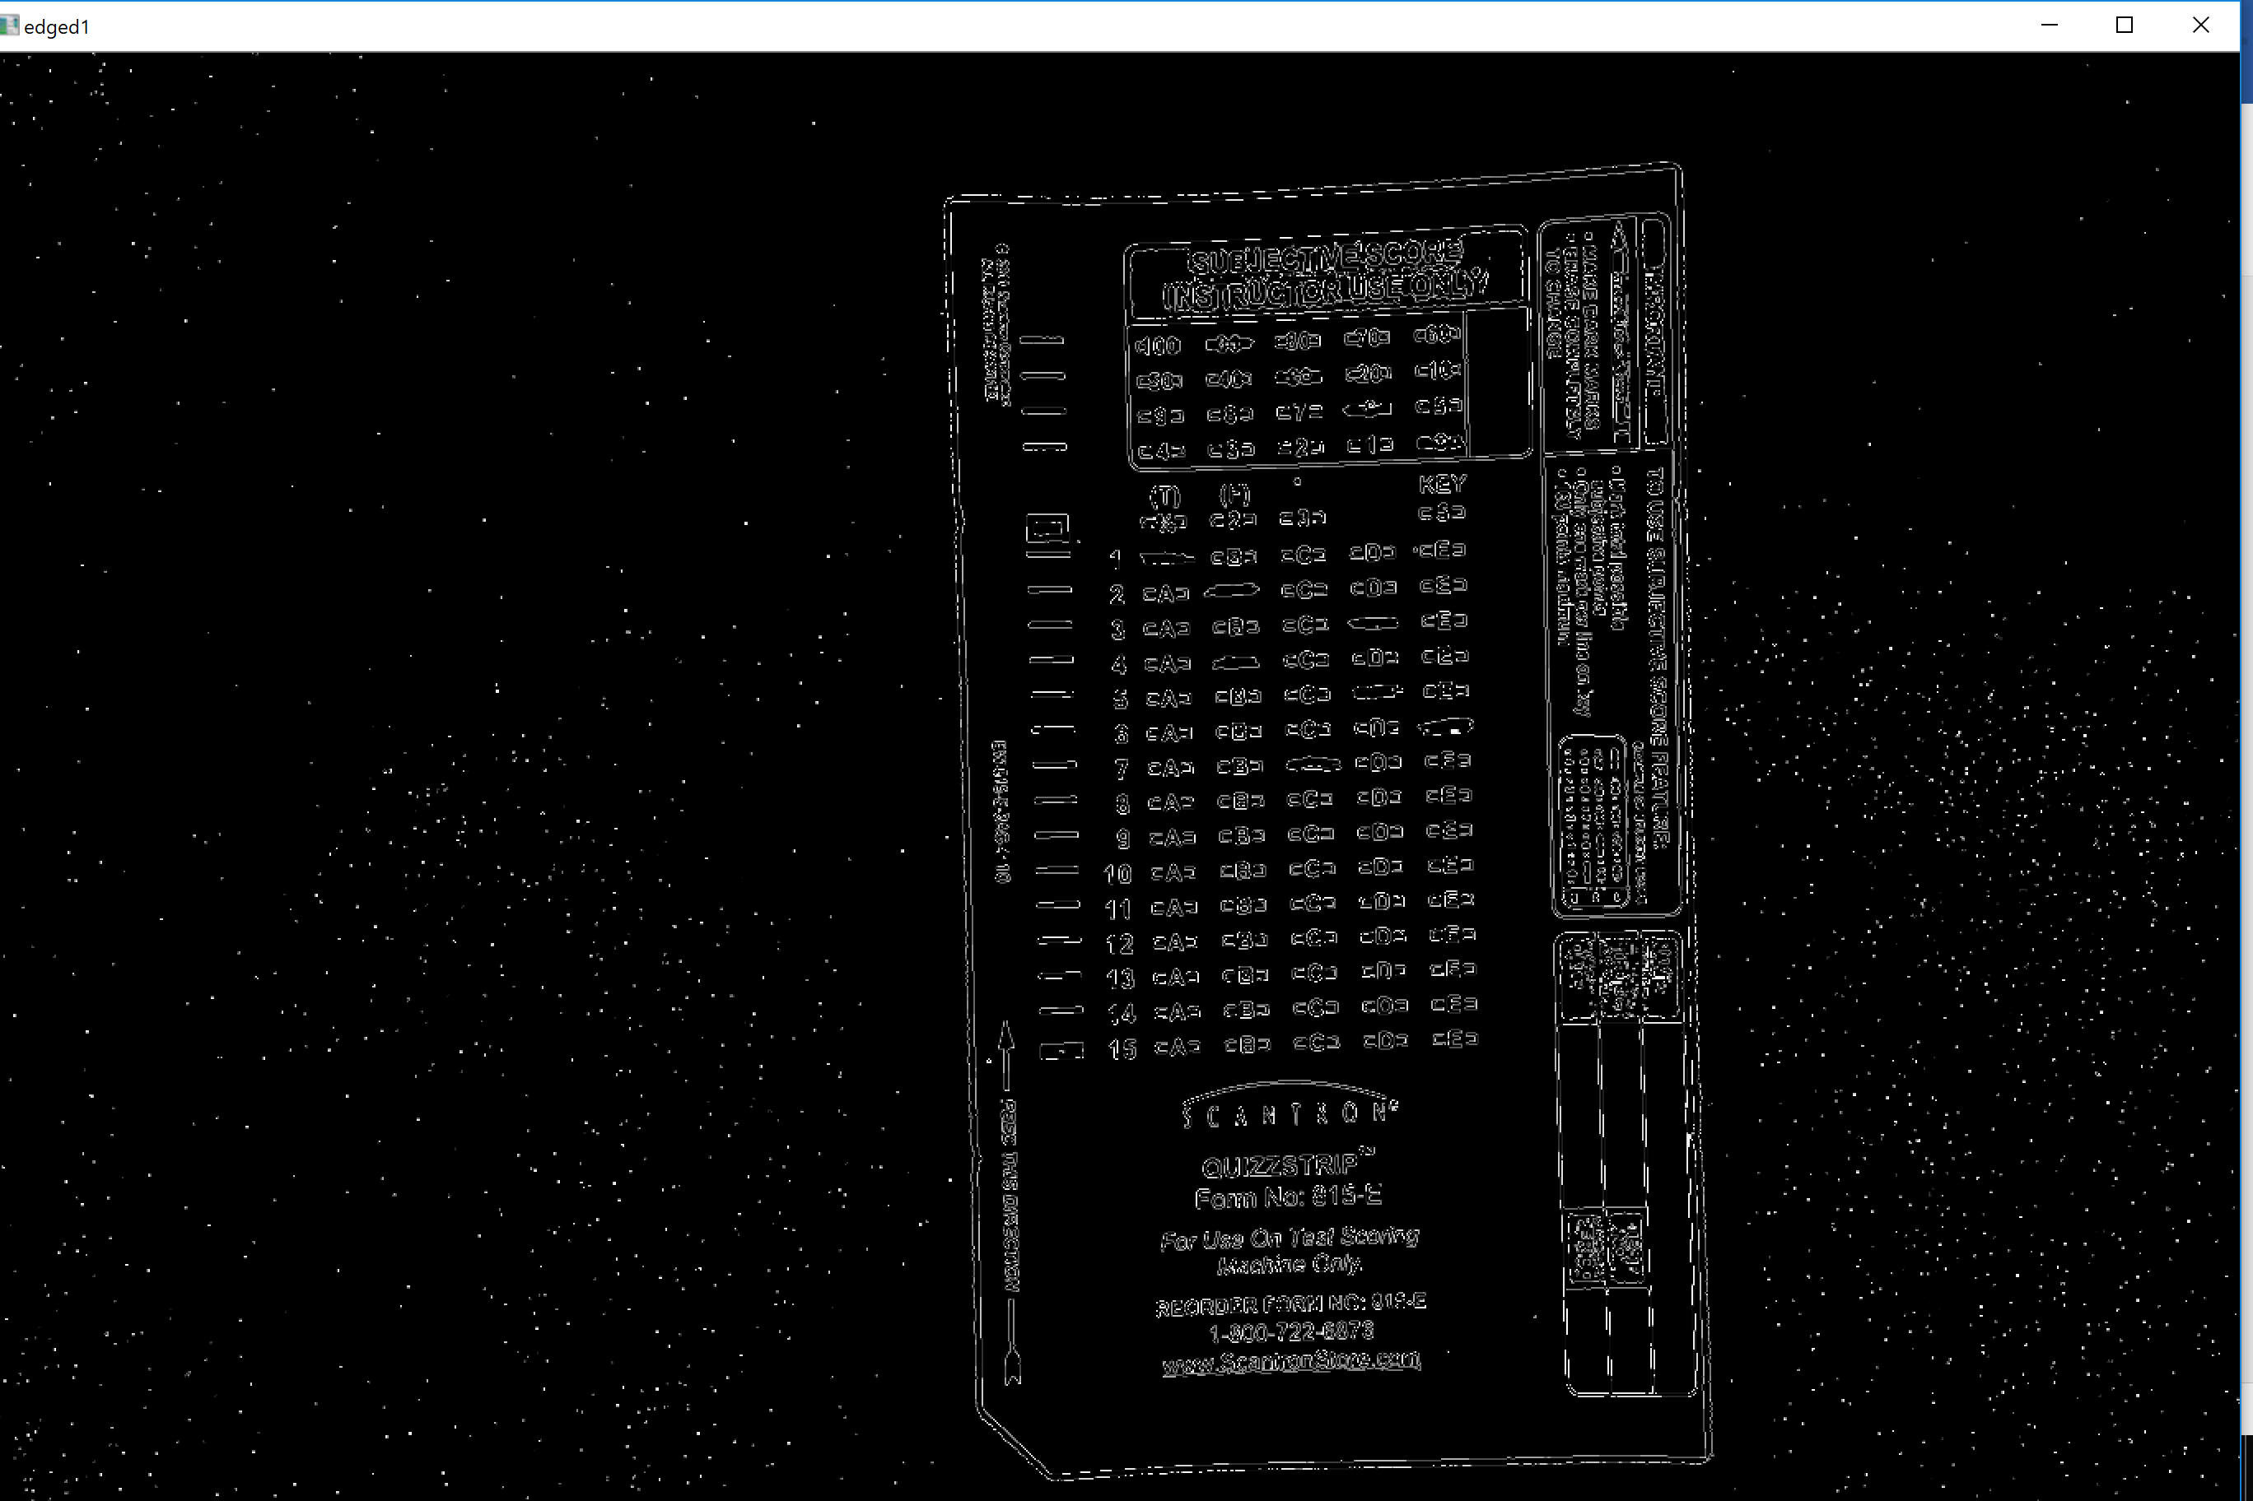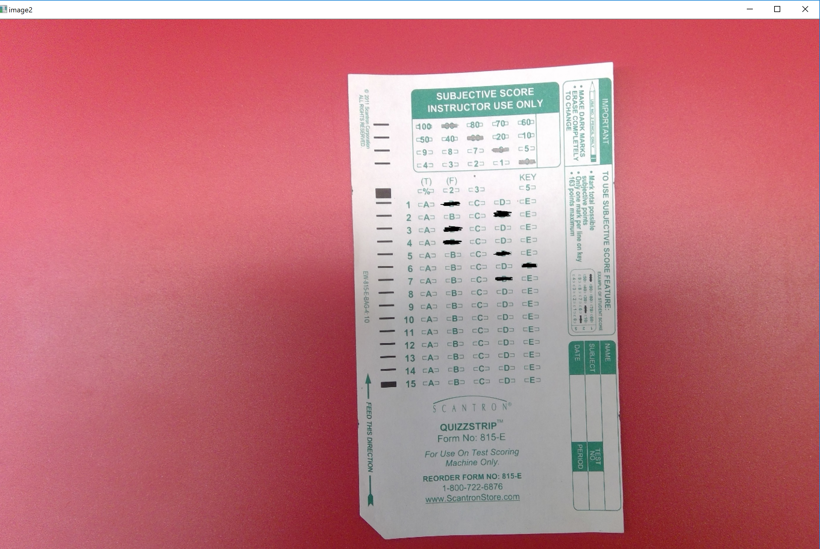

**Figure 2-8.** *edged1* **Figure 2-9.** *image1*

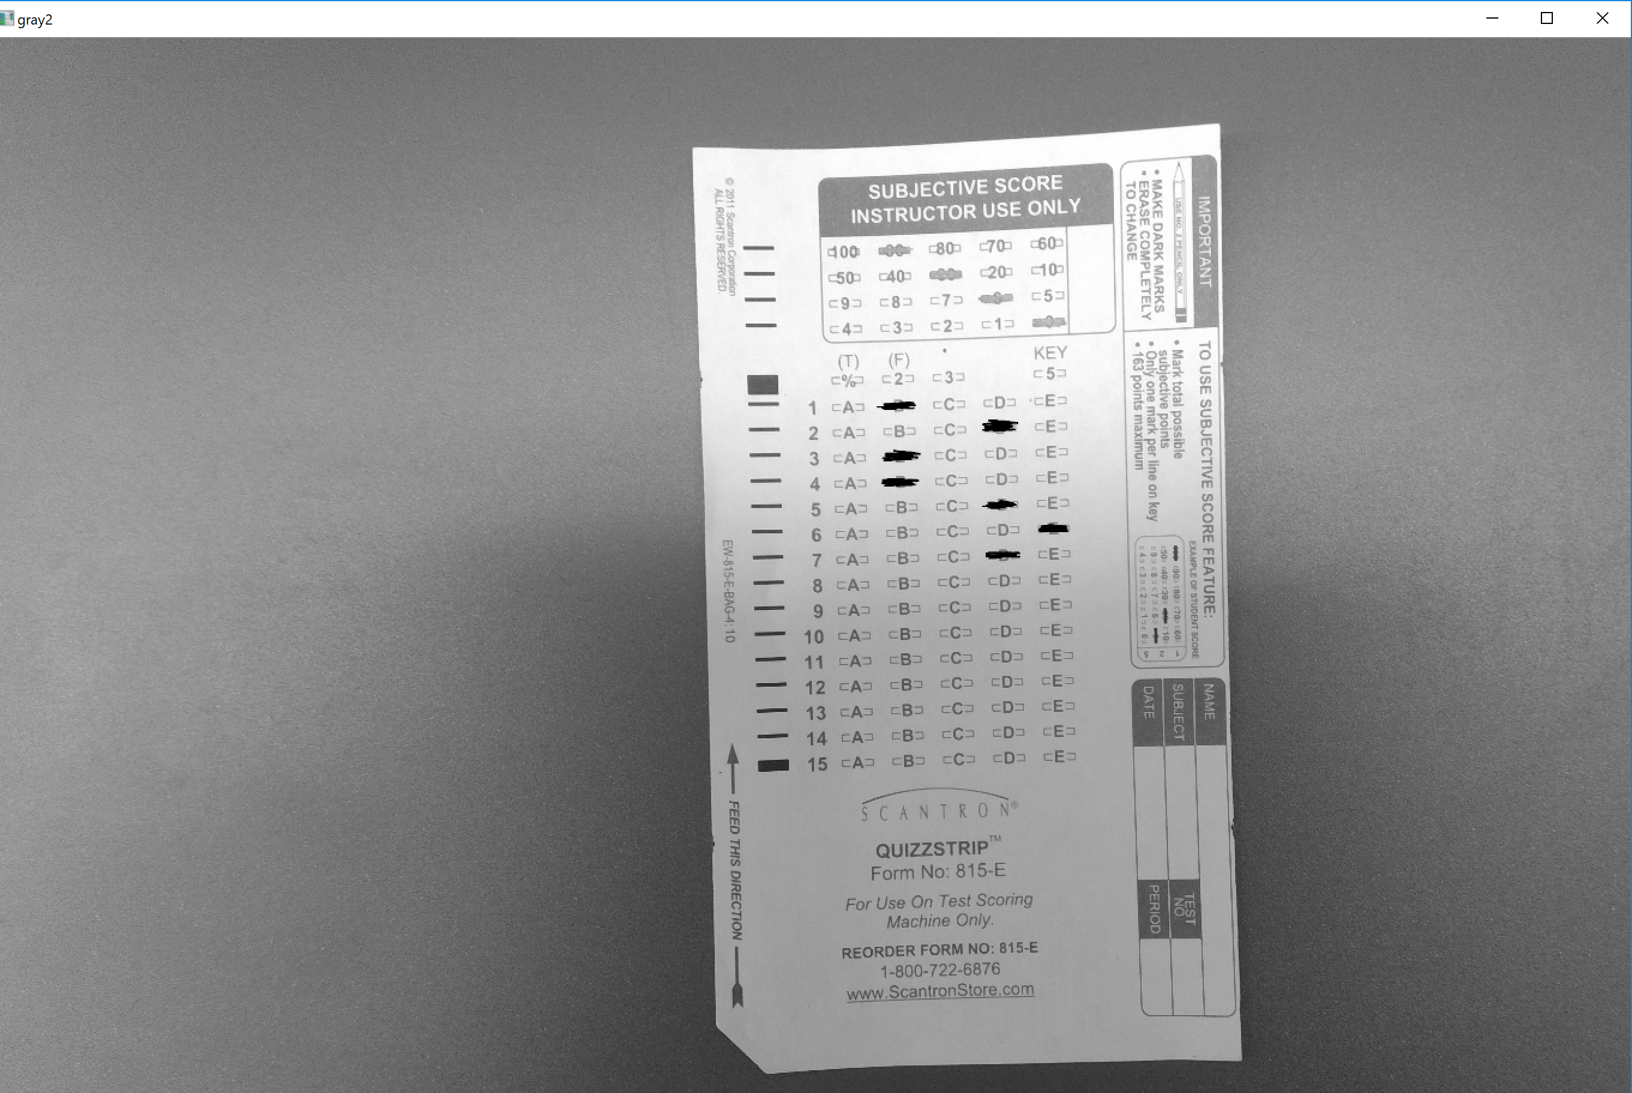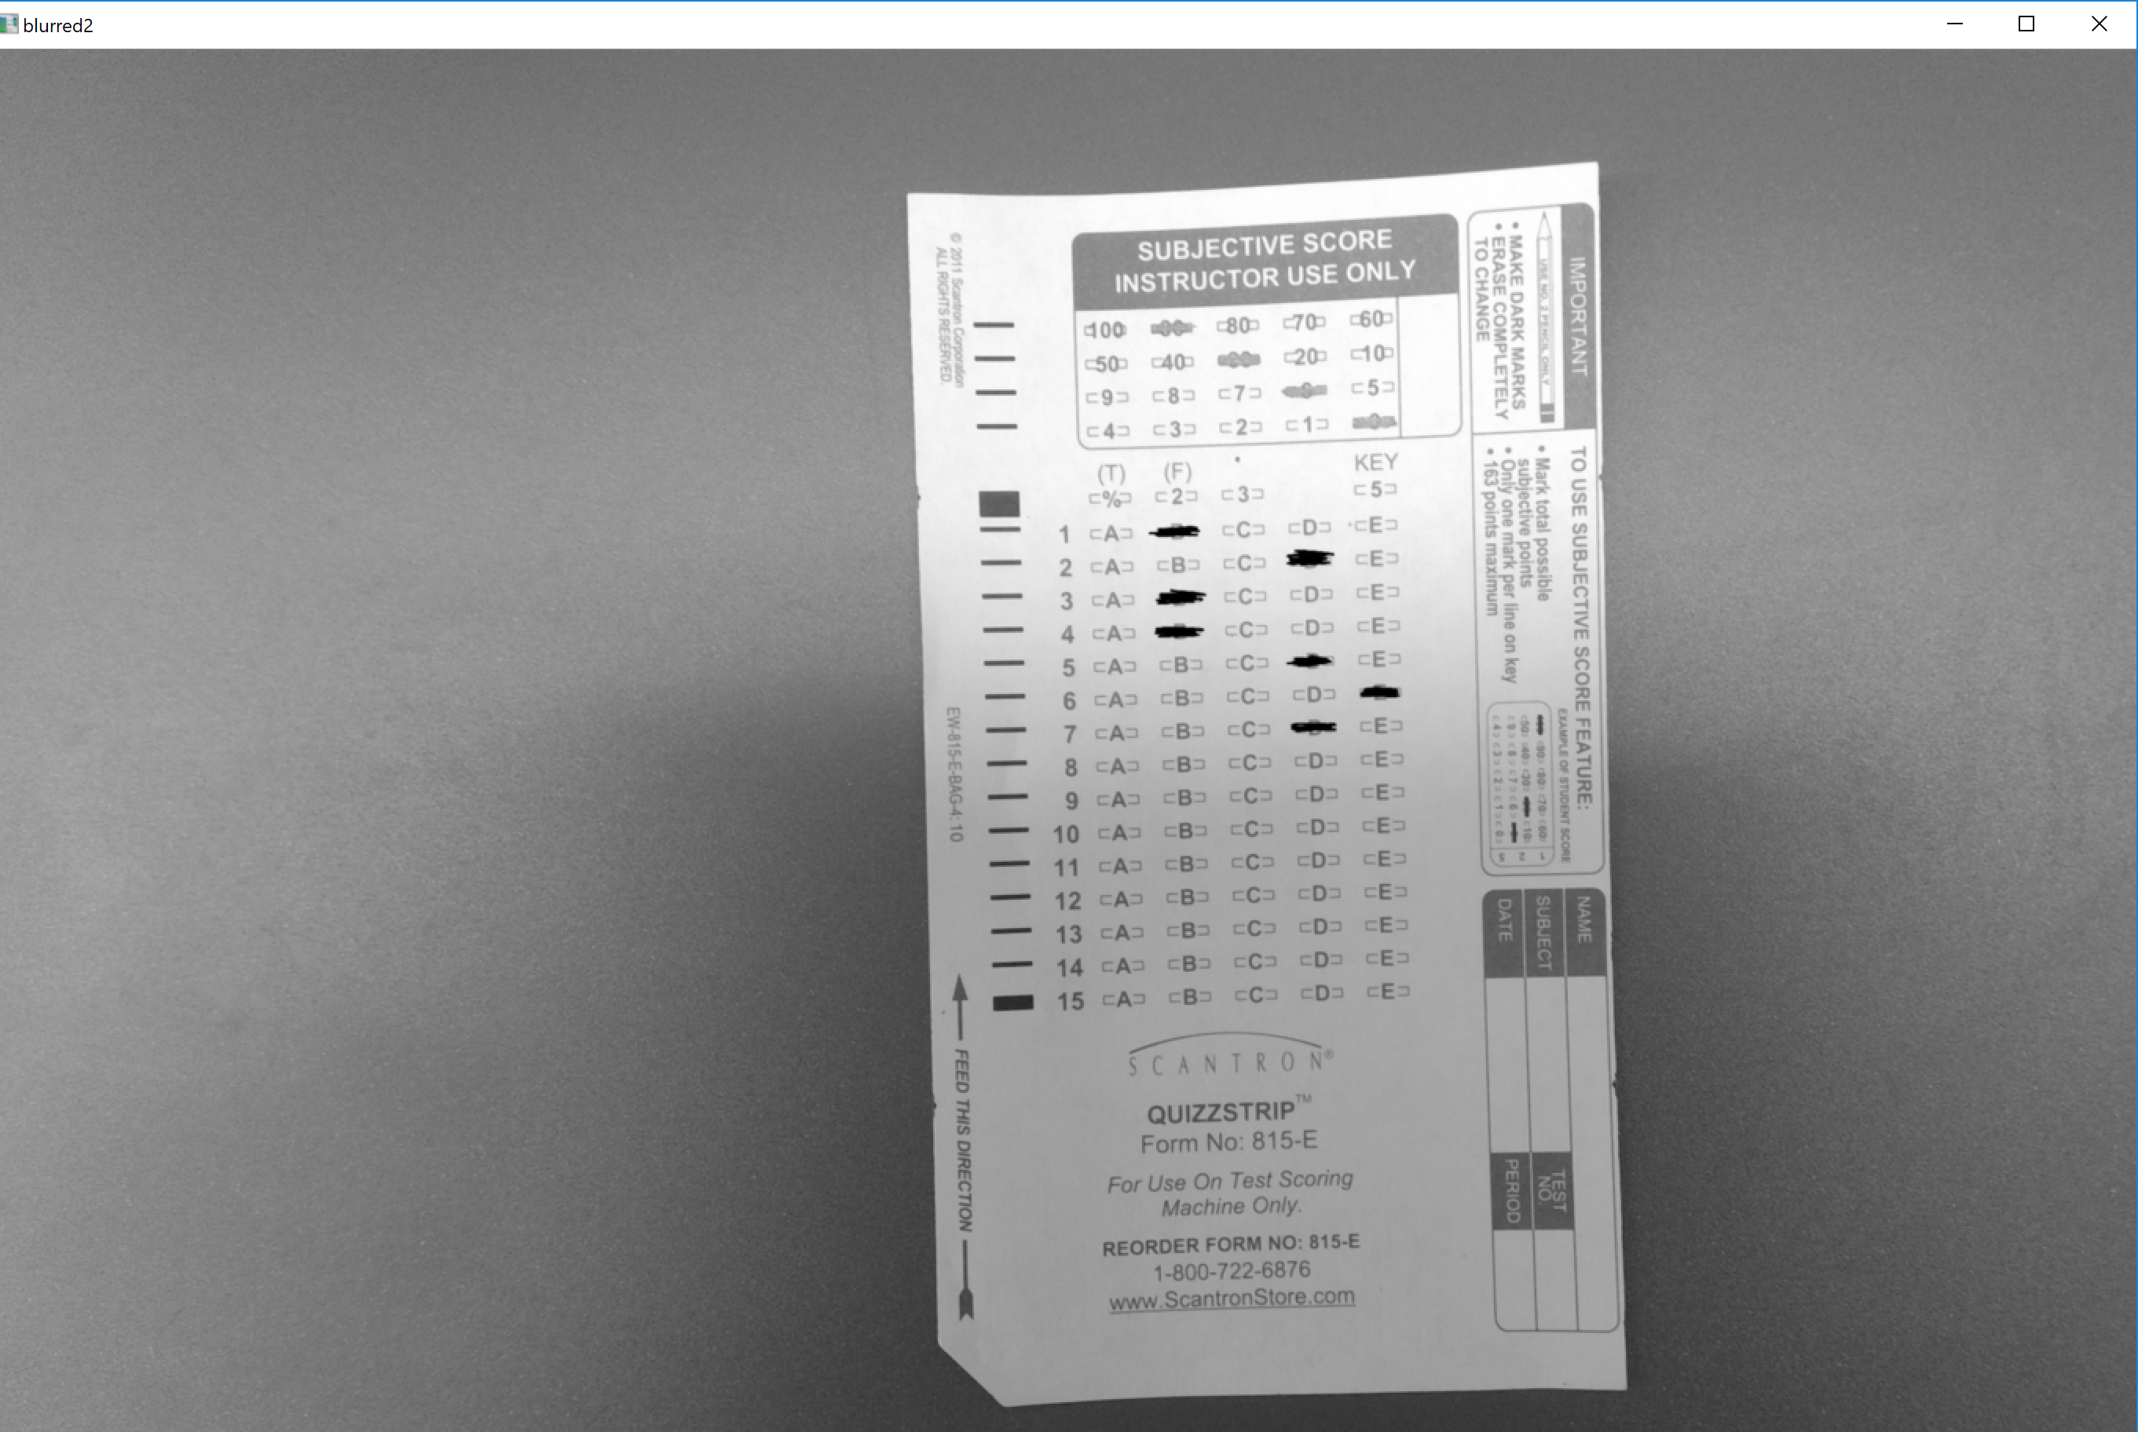

**Figure 2-10.** *gray1* **Figure 2-11.** *blurred1*

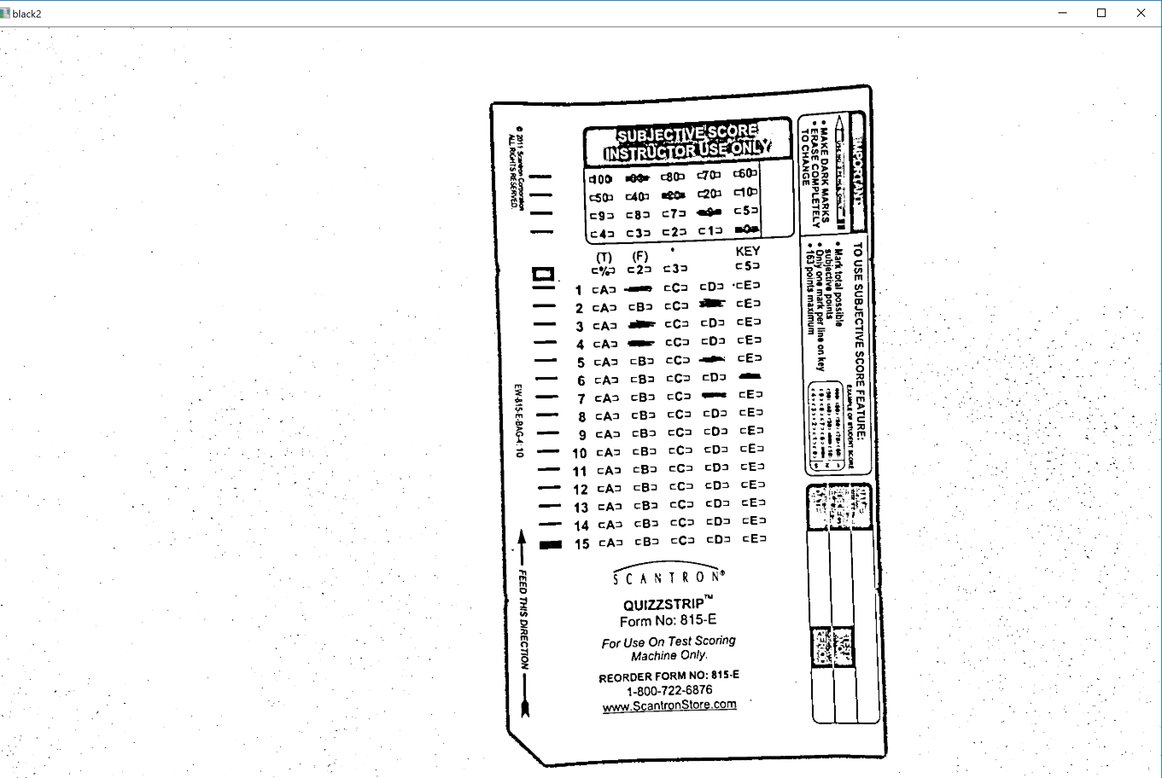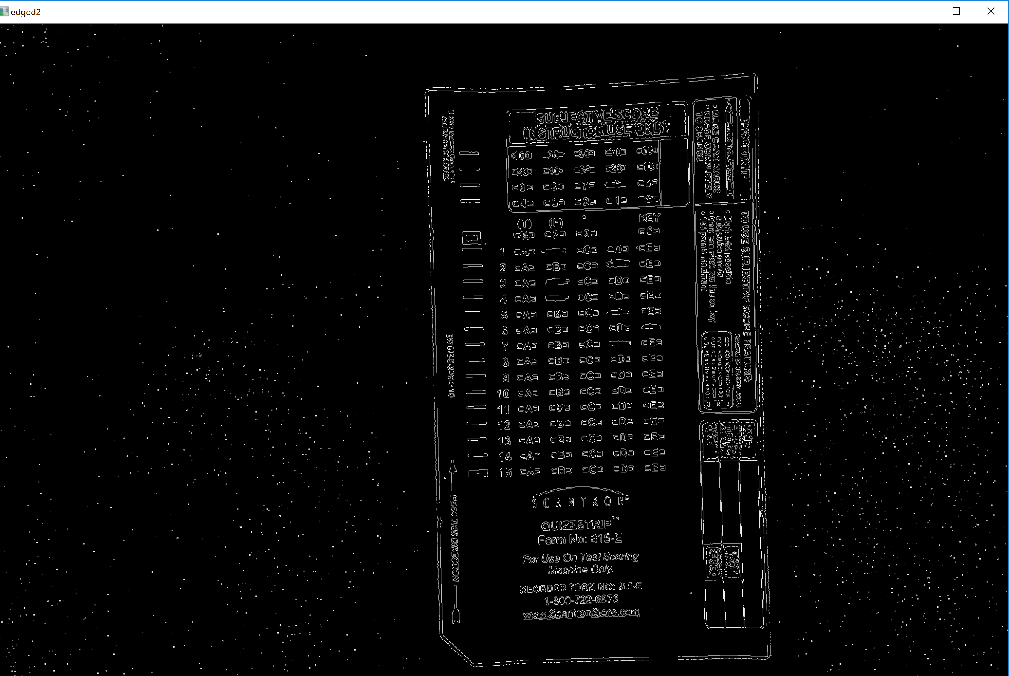

**Figure 2-12.** *black1* **Figure 2-13.** *edged1*



**Figure 2-14.** *Applying Transform*

We apply the four_point_transform function to both images with the code shown in **Figure 2-14**. We see that we take the calculated corner points and the grayscale image (gray1 and gray2) of the scantron for the transform, such that the resulting images are perfectly cropped grayscale images of the desired region of the scantrons. These are shown in **Figures 2-15** and **2-16**.

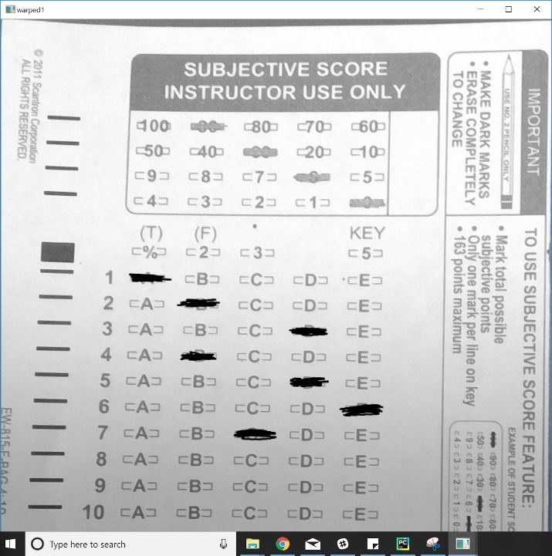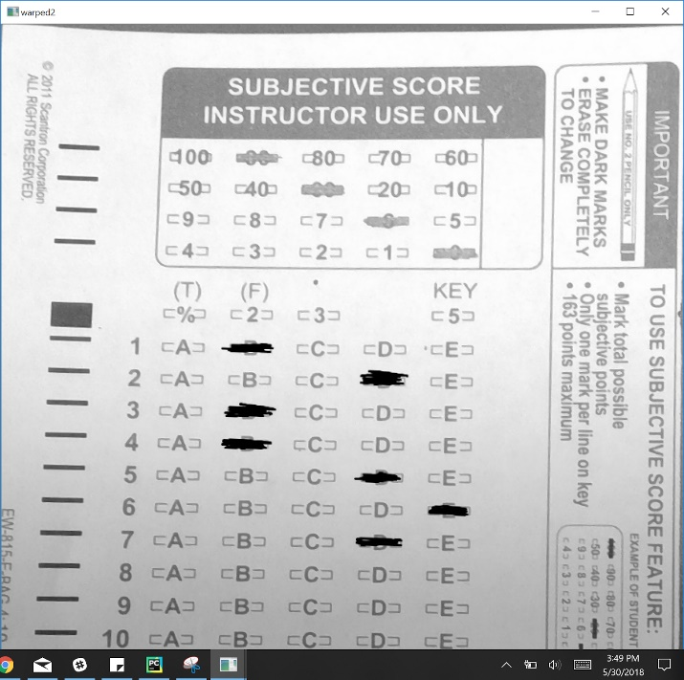

**Figure 2-15.** *Cropped Submission* **Figure 2-16.** *Cropped Answer Key*

We then need to prepare both images to be compared. Thus, we can see in **Figure 2-17** we apply a Gaussian blur to both images in line 157 and line 161. We then sharply define the contours and borders in the scantron in lines 158 and 162. Lines 159 and 163 were used only as a debugging step. Lines 168 to 170 is then what allows the blob detection software to work properly.

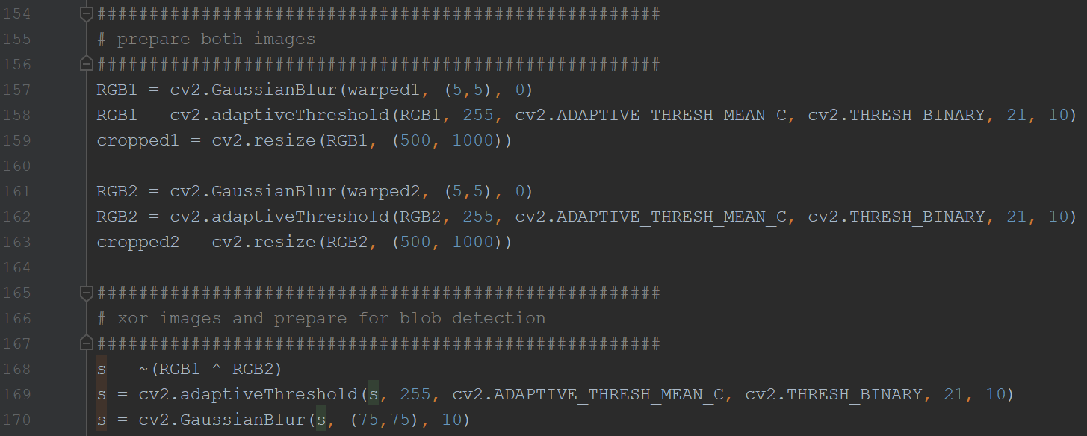

**Figure 2-17.** *Image Prep. and XNOR*

One of the key differences between implementation 1 and 2 is that while implementation 1 uses an AND to superimpose both scantrons onto a single image, implementation 2 uses XNOR in order to detect the differences between the images. We then apply another adaptiveThreshold function to sharply define the edges (line 169), and another gaussian blur to remove noise (line 170) all in an effort to prepare the image for blob detection. **Figure 2-18** shows the result of the XNOR of the two images. In **Figure 2-18** we can see that there exists two answers for the first three and last problems on the scantron due to the XNOR. Therefore, we can conclude that the submission is different than the answer key for these problems. These markings are far larger and bolder than the correct answers that are overlaid on top of each other, where the XNOR function created a whitespace in the overlapping marking area. These darker blotches are large and dark enough for the blob detection to recognize

*Note: The image in* ***Figure 2-18*** *is not the image being passed to the blob detection function as it still needs an adaptive threshold filter and a Gaussian blur to better allow the function to detect the blobs.*

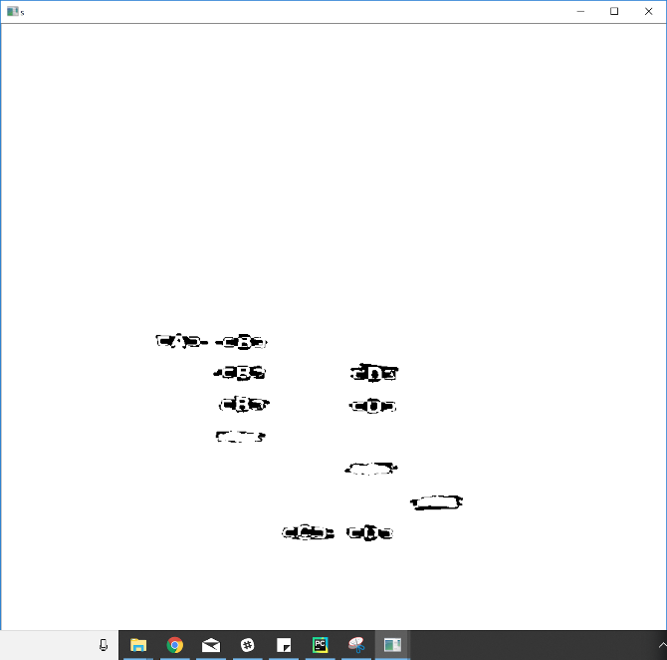

**Figure 2-18.** *Result of XNOR*

We then need to run the blob detection, whose code is shown in **Figure 2-19**.

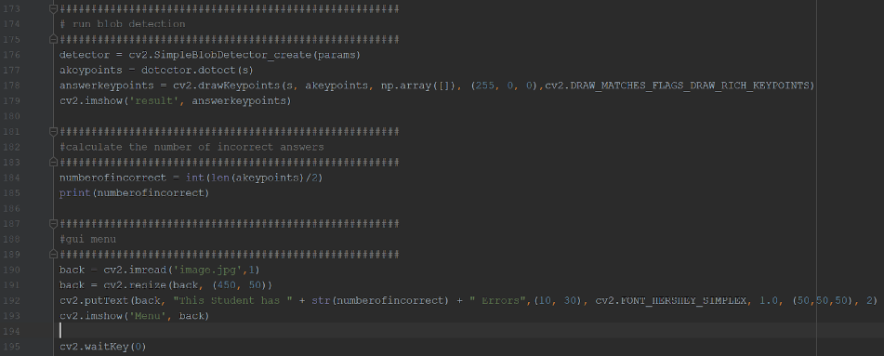

**Figure 2-19.** *Blob Detection and Output*

In order to properly use the blob detection function inherent to OpenCV, we must define the parameters similar to **Figure 1-1**. The parameters for this implementation are shown in **Figure 2-20**.

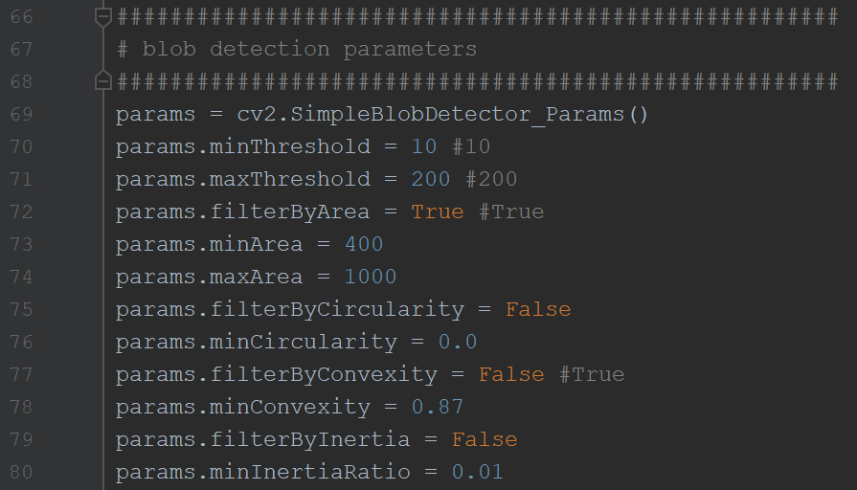

**Figure 2-20.** *Parameters of Blob Detection*

Using the parameters shown in **Figure 2-20** we create a blob detector object in line 176 and use it to find key points in line 177. These key points are then plotted onto the filtered and blurred version of **Figure 2-18** in line 178. The result of this is shown in **Figure 2-21**. Line 184 in **Figure 2-19** is then used to calculate the number of incorrect answers. We know that for every incorrect answer that exists, there are 2 markings on the image - one from the answer key, and another from the submission. Therefore, we can simply divide the number of blobs detected by 2 to acquire the number of incorrect answers. While the number of incorrect answers is printed to the console, a nicer GUI result is created and shown in lines 190 to 193. The result of this GUI is shown in **Figure 2-22**.

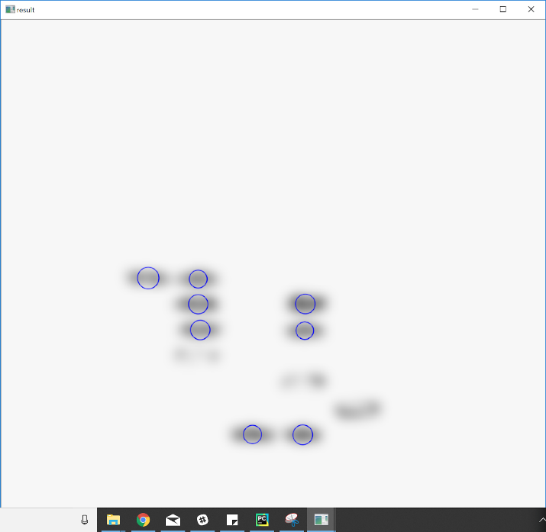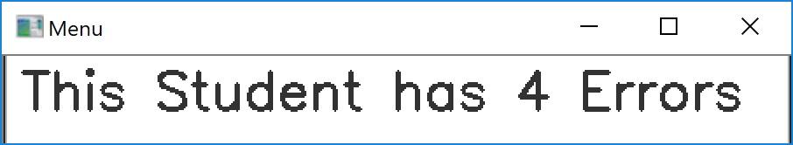

**Figure 2-21.** *Resulting Blob Detection* **Figure 2-22.** *GUI*

## Implementation 2: Advantages and Disadvantages

In theory this implementation is more flexible, allowing imperfect pictures (taken by human hands) to be used for grading due to the perspective transform. However, the perspective transform is extremely unreliable due to a combination of factors - the presence of many boxes and contours ON the scantron and the un-robustness of the algorithm. **Figure 2-23** shows a badly perspective transformed image as a result of this.

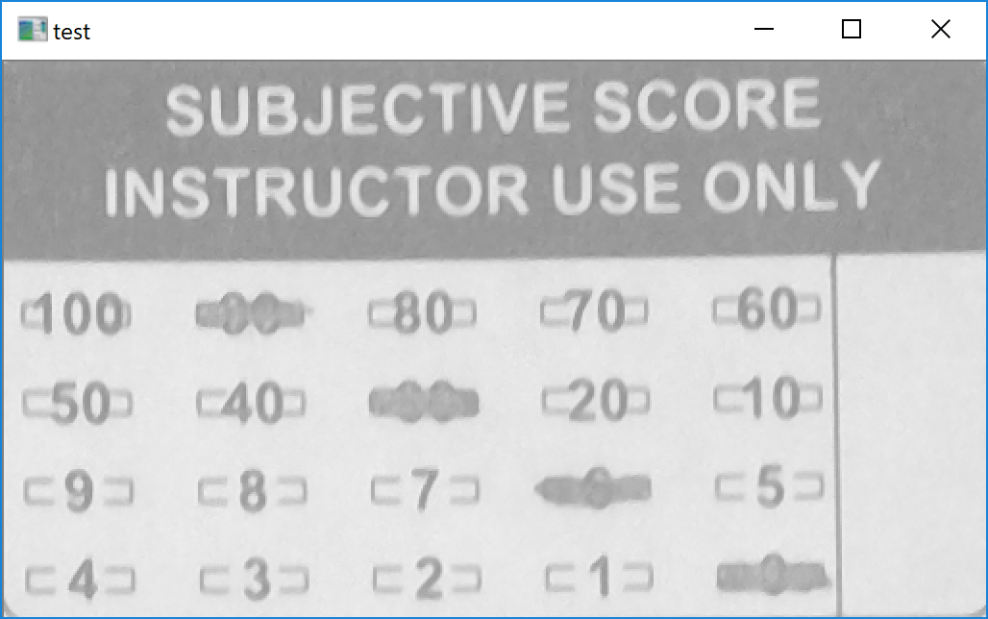

**Figure 2-23.** *Incorrect Perspective Transform*

While, the perspective transform did detect a valid border to which it can be applied, it is not the contour that we are looking for. Therefore, we see that because of this point of failure in the software, all the following image comparison and blob detection code will not properly work and will return garbage results.